NORTH WESTERN
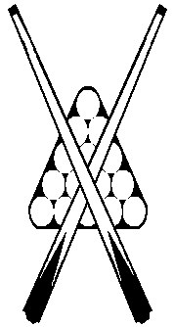
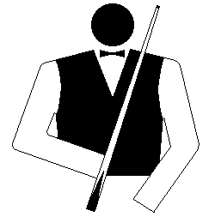
BILLIARDS & SNOOKER ASSOCIATION

2025 - NWBSA Billiards Championship
Burnie Club, April 5

Group A
1. Josh Burns
2. Geoff Lehman
2. Ricky Burns
4. Zachary Burns

Group A Matches (60 Minutes)
Geoff Lehman lt Ricky Burns 178-218
Josh Burns [52, 151] d Zachary Burns 431-144
Josh Burns [149, 124] d Ricky Burns 397-106
Geoff Lehman lt Zachary Burns [39] 199-237
Josh Burns [41, 57, 62] d Geoff Lehman 335-174
Ricky Burns lt Zachary Burns [37, 34] 176-287

Group A - Summary

Player | Won | Lost | For | Ag | Diff | Pl
Josh Burns | 3 | 0 | 1163 | 434 | 739 | 1
Geoff Lehman | 0 | 3 | 551 | 790 | -239 | 4
Ricky Burns | 1 | 2 | 500 | 862 | -362 | 3
Zachary Burns | 2 | 1 | 668 | 806 | -138 | 2

Final (120 Minutes)
Player | Breaks | Scores
Josh Burns | 167, 65, 107, 107, 53, 58, 56, 166 | 1047
Zachary Burns | 49 | 192

Highest Break: 167 - Josh Burns

