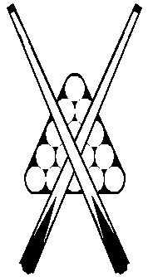



**NORTH WESTERN**

**BILLIARDS & SNOOKER ASSOCIATION**

ci (8) 2-0

**Grand Final**

October 5

**Penguin Bandits d Comets 3-1** at Penguin S&SC.

Rod Dunham (-18) d Josh Burns (-34) 3-1

Flinn Bennett (-8) lt Zachary Burns (0) 0-3

Scott Bennett (42) d Rendell Bugg (32) 3-1

Kurt Dunham (-52) d Ricky Burns (-8) 3-0

**Highest breaks -**

**Snooker:** 34, Flinn Bennett (Penguin Bandits), 30, Zachary Burns (Comets)

**Billiards:**

**Grand Final Best Player:** Zachary Burns (Comets)