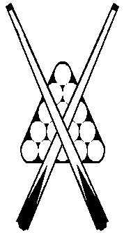



**NORTH WESTERN**

**BILLIARDS & SNOOKER ASSOCIATION**

**Finals**

**Preliminary Final**

**Devonport RSL** **lt Comets** **1-3** at Devonport RSL.

Scott Hodgetts (8) lt Josh Burns (-34) 0-2

Abdul Shaik (8) lt Ricky Burns (-4) 0-2

Ethan Brown (16) d Rendell Bugg (32) 2-0

Chris Sutton (30) lt Zachary Burns (20) 0-2

**Highest breaks –**

**Snooker:**

**Billiards:** 28, Zachary Burns (Comets).

**Grand Final:** Penguin Bandits v Comets

(at Penguin Sports & Services Club)

**Sunday, October 5**

**Commencing at 2:00pm**