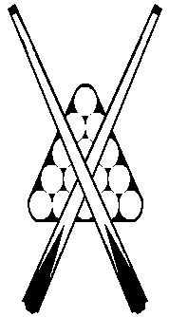

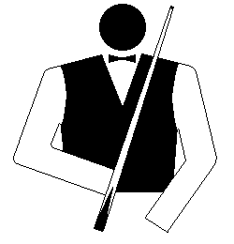

**NORTH WESTERN**

**BILLIARDS & SNOOKER ASSOCIATION**

**Finals**

**Second Semi Final**

**Penguin Bandits d Devonport RSL 3-0** at Penguin S&SC.

Rod Dunham (-18) d Abdul Shaik (8) 2-1

Flinn Bennett (-8) d Corey Mansson (14) 2-1

Scott Bennett (42) u/f Ethan Brown (16) 0-0

Kurt Dunham (-52) d Chris Sutton (30) 2-1

**Highest breaks –**

**Billiards:** 72, 48, 44, Kurt Dunham (Penguin Bandits). 33, 29, Chris Sutton (Devonport RSL).

**Snooker:**

**First Semi Final**

**Penguin Black lt Comets 1-3** at Penguin S&SC.

Bob Boutcher (10) lt Josh Burns (-34) 1-2

Andrew Fisher (20) lt Zachary Burns (0) 1-2

Garry Beaton (34) lt Rendell Bugg (32) 1-2

Ian Cornick (68) d Ricky Burns (-8) 2-1

**Highest breaks –**

**Billiards:** 21, Ian Cornick (Penguin Black), 20, Ricky Burns (Comets)

**Snooker:** 92c, Josh Burns (Comets)

**Monday, September 29**

**Preliminary Final:** Devonport RSL v Comets (at Devonport RSL Club)